Completing a Performance Evaluation

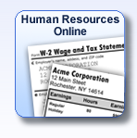 | Log into your MyPaychex.com account and choose the Human Resources Online program.
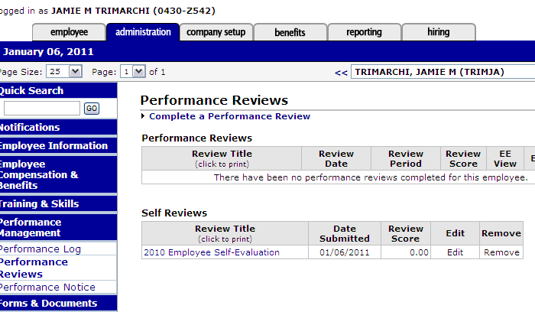 | Make sure you are on the Administration tab.  Under the Performance Management section on the left side, click on Performance Reviews.  In the center of the toolbar, choose the employee’s name from the dropdown menu (see arrow).  Here you can see Self Reviews your employees have completed. When you are ready, click Complete a Performance Review.
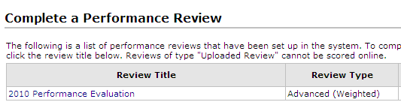 | Choose the 2010 Performance Evaluation.
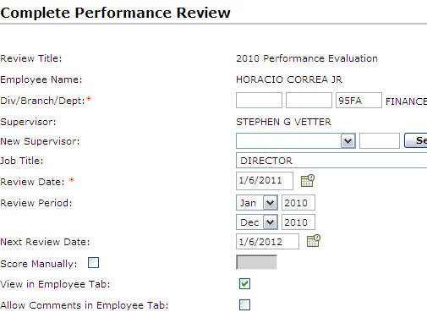 | Change the Review Period to January – December 2010.  Check the box for View in Employee Tab so that your employee will be able to read their review. If your review is not finalized and don’t wish your employee to see it, you can leave this box unchecked.
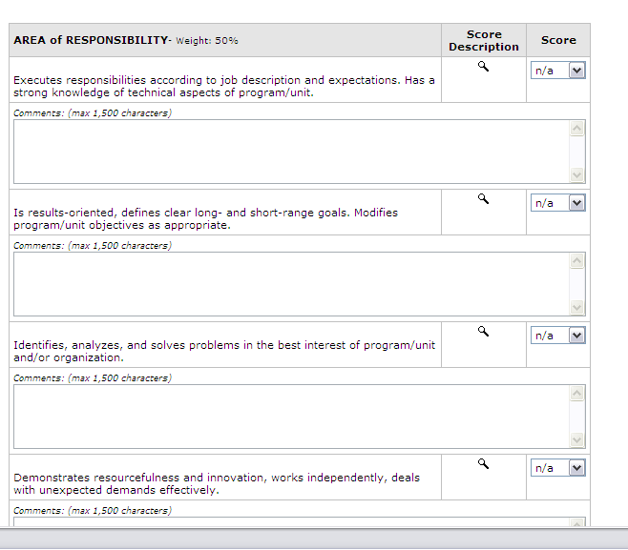 | Each section will tell you its percentage Weight of the final score.  Rate each item using the dropdown menu in the Score column.  (Shortcut: If you “tab” into this field, you can simply type the number you want.)  To see the rating definition, click the magnifying glass. Each rating has the same definition throughout the evaluation.  Comments can be added below every item, and at the end of every section.
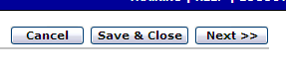 | On the right side of the click Next.
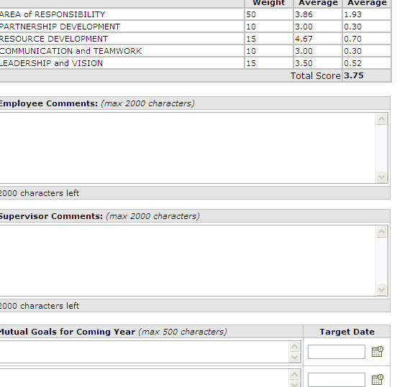 | The employee’s score will be displayed in detail in the Scoring Summary section.  Do not complete the Employee Comments section. The employee’s self-review with comments and/or a written memo from the employee can be attached to your evaluation when submitted.  The Supervisor Comments and Goals sections are optional. If these require further discussion, they may be submitted later.
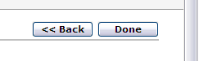 | When your review is complete, click Done.
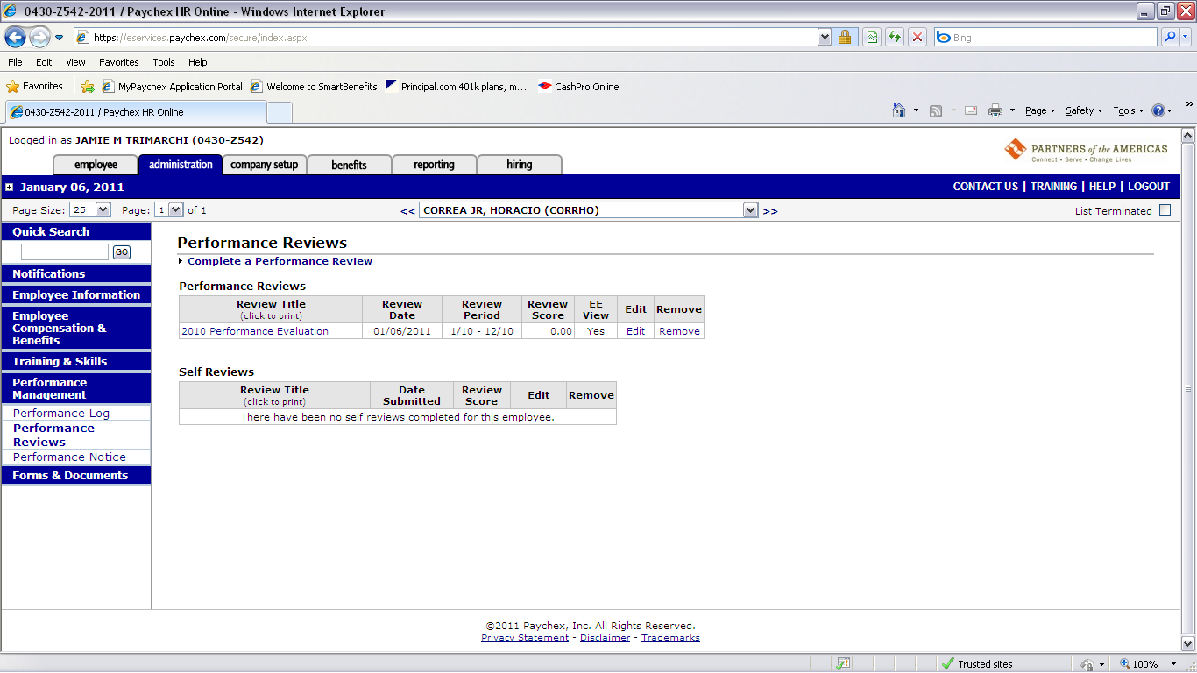 | You will be brought back to the Performance Reviews section. Click on your review to view.
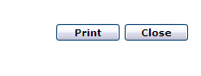 | Your review will come in a pop-up window. Click Print to print your review. There will be a signature line for you and the employee.
In the Performance Reviews section, to the right of your review title, you will see options for Edit and Remove (Delete).

You will be able to edit your review until Sunday, January 30. On Monday morning I will lock the evaluations and no changes will be allowed, as evaluations must be printed, signed and submitted to the President that morning at the latest.

